# HW Set 9 7.48

x1 = c(418, 421, 421, 422, 425, 427, 431,

434, 437, 439, 446, 447, 448, 453,

454, 463, 465)

x2 = c(429, 430, 430, 431, 436, 437, 440,

441, 445, 446, 447)

# a) Construct a boxplot

boxplot(x1, x2)

# Their means are about to be same, but

# the variance of x1 is greater than x2

# b)

n.x1 = length(x1)

n.x2 = length(x2)

mean.x1 = mean(x1)

mean.x2 = mean(x)2

s.x1 = sd(x1)

s.x2 = sd(x2)

df = (s.x1 ^ 2 / n.x1 + s.x2 ^ 2 / n.x2) ^ 2 / ((s.x1 ^ 2 / n.x1) ^ 2

/ (n.x1 - 1) + (s.x2 ^ 2 / n.x2) ^ 2 / (n.x2 - 1))

c(mean.x1 - mean.x2 - 2.069 * sqrt(s.x1 ^ 2 / n.x1 + s.x2 ^ 2 / n.x2),

mean.x1 - mean.x2 + 2.069 * sqrt(s.x1 ^ 2 / n.x1 + s.x2 ^ 2 / n.x2))

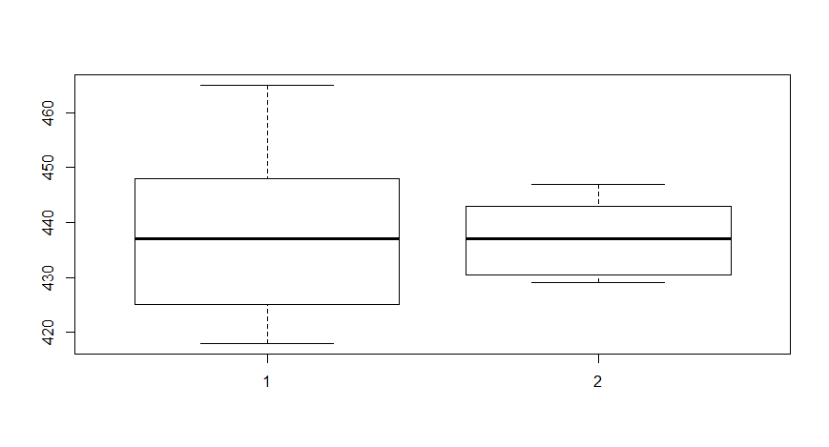

# 7.53

x1 = c(42.8, 55.6, 49.0, 48.7, 44.1,

55.4, 50.1, 45.7, 51.4, 43.1,

46.8, 46.7, 47.7, 45.8, 45.4)

x2 = c(90.0, 93.1, 86.3, 90.3, 88.5,

88.1, 93.2, 90.8, 90.1, 92.6,

88.2, 88.6, 91.0, 90.0, 90.1)

# a)

boxplot(x1, x2)

# Completely different range and location.

# The variances are also somehow different

# b)

d = x2 - x1

d.mean = mean(d)

s.d = sd(d)

t.test(d)

qqnorm(d)

